Tarea Cerchas en 3D

Por: Cesar Fernando Gamba Tiusaba

Código: 215524

Problema.

A = 1 $m^{2}$ para todos los elementos.

AE = 24855578 KPa

2AE = 27789382 KPa

2AE

**Resultados SAP2000.**

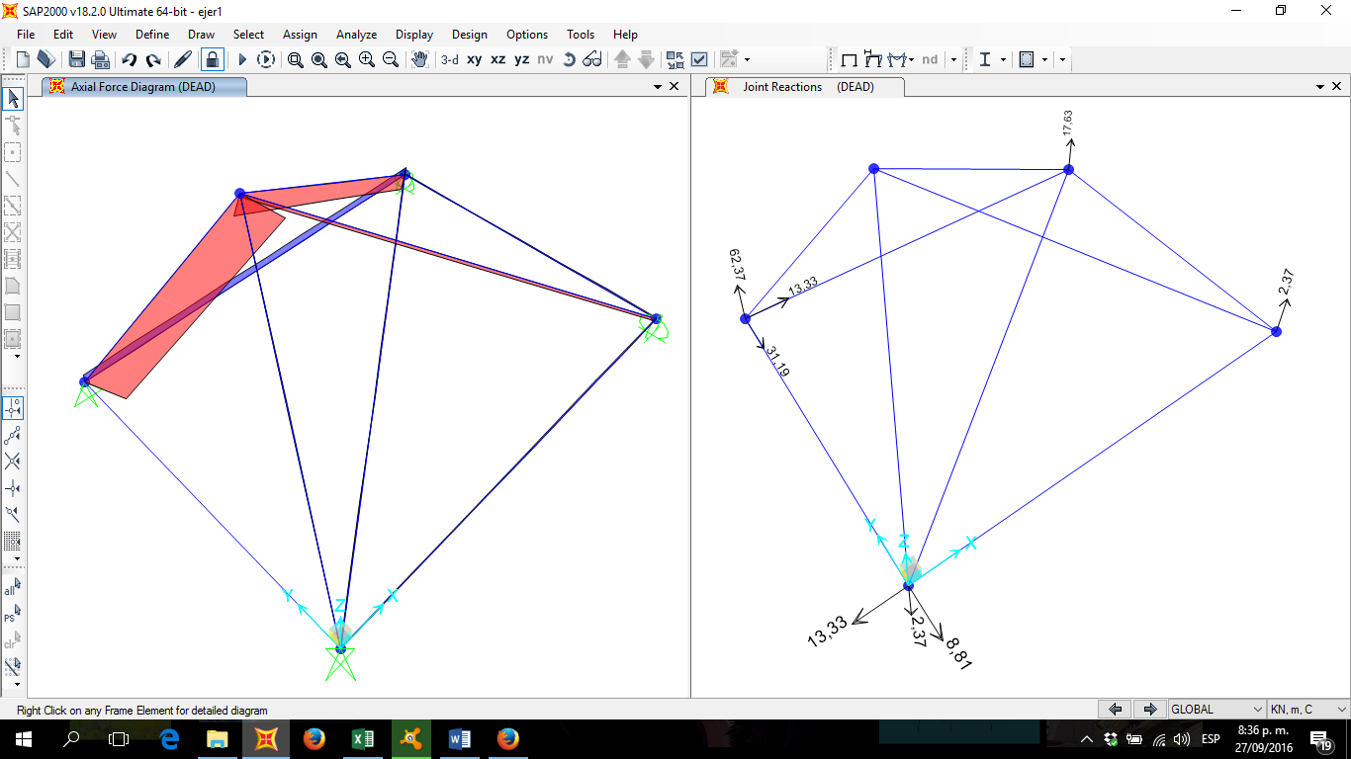

AE

AE

2AE

2AE

AE

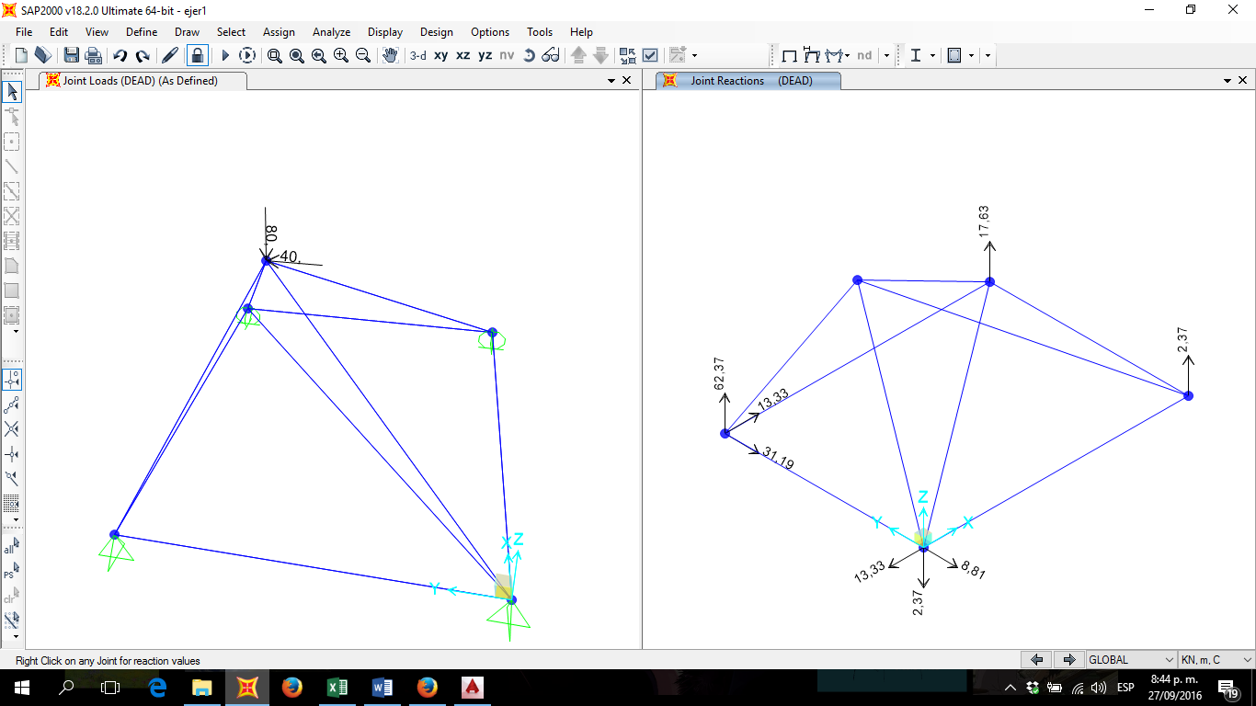

**Resultados Excel.**

Matriz de reacciones en los apoyos.

Como se puede observar los resultados entregados por SAP son exactamente los mismos a los resultados encontrados en EXCEL.

|  |  |
| --- | --- |
| Fuerzas desconocidas (KN) | |
| GL | 1 |
| 8 | -13,333333 |
| 9 | -8,8128518 |
| 10 | -2,3742965 |
| 11 | 2,37429647 |
| 12 | 17,6257035 |
| 13 | 13,3333333 |
| 14 | -31,187148 |
| 15 | 62,3742965 |

Desplazamientos desconocidos.

|  |  |
| --- | --- |
| Desplazamientos desconocidos(m) | |
| GL | 1 |
| 1 | 0,0000015131065 |
| 2 | 0,0000065767746 |
| 3 | -0,0000066885430 |
| 4 | 0,0000005126339 |
| 5 | -0,0000001153131 |
| 6 | 0,0000025698758 |
| 7 | 0,0000001712580 |

Matrizes de rigidez de cada elemento.

Los grados de libertad y la numeracion de los nodos y elementos fue echa de la misma manera como se hizo en clase.

|  |  |  |  |  |  |  |
| --- | --- | --- | --- | --- | --- | --- |
| Elemento 1-2 | | | | | | |
|  | **8** | **9** | **10** | **4** | **5** | **11** |
| 8 | 6947345,5 | 0 | 0 | -6947345,5 | 0 | 0 |
| 9 | 0 | 0 | 0 | 0 | 0 | 0 |
| 10 | 0 | 0 | 0 | 0 | 0 | 0 |
| 4 | -6947345,5 | 0 | 0 | 6947345,5 | 0 | 0 |
| 5 | 0 | 0 | 0 | 0 | 0 | 0 |
| 11 | 0 | 0 | 0 | 0 | 0 | 0 |

|  |  |  |  |  |  |  |
| --- | --- | --- | --- | --- | --- | --- |
| Elemento 4-3 | | | | | | |
|  | **13** | **14** | **15** | **6** | **7** | **12** |
| 13 | 6947345,5 | 0 | 0 | -6947345,5 | 0 | 0 |
| 14 | 0 | 0 | 0 | 0 | 0 | 0 |
| 15 | 0 | 0 | 0 | 0 | 0 | 0 |
| 6 | -6947345,5 | 0 | 0 | 6947345,5 | 0 | 0 |
| 7 | 0 | 0 | 0 | 0 | 0 | 0 |
| 12 | 0 | 0 | 0 | 0 | 0 | 0 |

|  |  |  |  |  |  |  |
| --- | --- | --- | --- | --- | --- | --- |
| Elemento 2-3 | | | | | | |
|  | **4** | **5** | **11** | **6** | **7** | **12** |
| 4 | 0 | 0 | 0 | 0 | 0 | 0 |
| 5 | 0 | 8285192,67 | 0 | 0 | -8285192,7 | 0 |
| 11 | 0 | 0 | 0 | 0 | 0 | 0 |
| 6 | 0 | 0 | 0 | 0 | 0 | 0 |
| 7 | 0 | -8285192,7 | 0 | 0 | 8285192,67 | 0 |
| 12 | 0 | 0 | 0 | 0 | 0 | 0 |

|  |  |  |  |  |  |  |
| --- | --- | --- | --- | --- | --- | --- |
| Elemento 1-4 | | | | | | |
|  | **8** | **9** | **10** | **13** | **14** | **15** |
| 8 | 0 | 0 | 0 | 0 | 0 | 0 |
| 9 | 0 | 8285192,67 | 0 | 0 | -8285192,7 | 0 |
| 10 | 0 | 0 | 0 | 0 | 0 | 0 |
| 13 | 0 | 0 | 0 | 0 | 0 | 0 |
| 14 | 0 | -8285192,7 | 0 | 0 | 8285192,67 | 0 |
| 15 | 0 | 0 | 0 | 0 | 0 | 0 |

|  |  |  |  |  |  |  |
| --- | --- | --- | --- | --- | --- | --- |
| Elemento 1-5 | | | | | | |
|  | **8** | **9** | **10** | **1** | **2** | **3** |
| 8 | 920576,963 | 1841153,93 | 1841153,93 | -920576,96 | -1841153,9 | -1841153,9 |
| 9 | 1841153,93 | 3682307,85 | 3682307,85 | -1841153,9 | -3682307,9 | -3682307,9 |
| 10 | 1841153,93 | 3682307,85 | 3682307,85 | -1841153,9 | -3682307,9 | -3682307,9 |
| 1 | -920576,96 | -1841153,9 | -1841153,9 | 920576,963 | 1841153,93 | 1841153,93 |
| 2 | -1841153,9 | -3682307,9 | -3682307,9 | 1841153,93 | 3682307,85 | 3682307,85 |
| 3 | -1841153,9 | -3682307,9 | -3682307,9 | 1841153,93 | 3682307,85 | 3682307,85 |

|  |  |  |  |  |  |  |
| --- | --- | --- | --- | --- | --- | --- |
| Elemento 2-5 | | | | | | |
|  | **4** | **5** | **11** | **1** | **2** | **3** |
| 4 | 3568190,36 | -2378793,6 | -2378793,6 | -3568190,4 | 2378793,58 | 2378793,58 |
| 5 | -2378793,6 | 1585862,38 | 1585862,38 | 2378793,58 | -1585862,4 | -1585862,4 |
| 11 | -2378793,6 | 1585862,38 | 1585862,38 | 2378793,58 | -1585862,4 | -1585862,4 |
| 1 | -3568190,4 | 2378793,58 | 2378793,58 | 3568190,36 | -2378793,6 | -2378793,6 |
| 2 | 2378793,58 | -1585862,4 | -1585862,4 | -2378793,6 | 1585862,38 | 1585862,38 |
| 3 | 2378793,58 | -1585862,4 | -1585862,4 | -2378793,6 | 1585862,38 | 1585862,38 |

|  |  |  |  |  |  |  |
| --- | --- | --- | --- | --- | --- | --- |
| Elemento 3-5 | | | | | | |
|  | **6** | **7** | **12** | **1** | **2** | **3** |
| 6 | 4774515,91 | 1591505,3 | -3183010,6 | -4774515,9 | -1591505,3 | 3183010,61 |
| 7 | 1591505,3 | 530501,768 | -1061003,5 | -1591505,3 | -530501,77 | 1061003,54 |
| 12 | -3183010,6 | -1061003,5 | 2122007,07 | 3183010,61 | 1061003,54 | -2122007,1 |
| 1 | -4774515,9 | -1591505,3 | 3183010,61 | 4774515,91 | 1591505,3 | -3183010,6 |
| 2 | -1591505,3 | -530501,77 | 1061003,54 | 1591505,3 | 530501,768 | -1061003,5 |
| 3 | 3183010,61 | 1061003,54 | -2122007,1 | -3183010,6 | -1061003,5 | 2122007,07 |

|  |  |  |  |  |  |  |
| --- | --- | --- | --- | --- | --- | --- |
| Elemento 4-5 | | | | | | |
|  | **13** | **14** | **15** | **1** | **2** | **3** |
| 13 | 1691207,87 | -1691207,9 | 3382415,74 | -1691207,9 | 1691207,87 | -3382415,7 |
| 14 | -1691207,9 | 1691207,87 | -3382415,7 | 1691207,87 | -1691207,9 | 3382415,74 |
| 15 | 3382415,74 | -3382415,7 | 6764831,48 | -3382415,7 | 3382415,74 | -6764831,5 |
| 1 | -1691207,9 | 1691207,87 | -3382415,7 | 1691207,87 | -1691207,9 | 3382415,74 |
| 2 | 1691207,87 | -1691207,9 | 3382415,74 | -1691207,9 | 1691207,87 | -3382415,7 |
| 3 | -3382415,7 | 3382415,74 | -6764831,5 | 3382415,74 | -3382415,7 | 6764831,48 |

|  |  |  |  |  |  |  |
| --- | --- | --- | --- | --- | --- | --- |
| Elemento 1-3 | | | | | | |
|  | **8** | **9** | **10** | **6** | **7** | **12** |
| 8 | 3181513,98 | 2386135,49 | 0 | -3181514 | -2386135,5 | 0 |
| 9 | 2386135,49 | 1789601,62 | 0 | -2386135,5 | -1789601,6 | 0 |
| 10 | 0 | 0 | 0 | 0 | 0 | 0 |
| 6 | -3181514 | -2386135,5 | 0 | 3181513,98 | 2386135,49 | 0 |
| 7 | -2386135,5 | -1789601,6 | 0 | 2386135,49 | 1789601,62 | 0 |
| 12 | 0 | 0 | 0 | 0 | 0 | 0 |